**K8S APP ARMOR**

SECCOMP can restrict the system calls for a pod but cannot restrict a program’s access to specific objects, such as files or a directory.

AppArmor is a linux security module to confine a program to a limited set of resources.

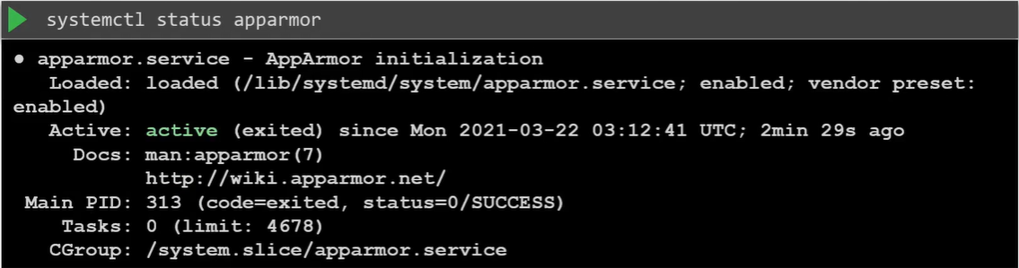

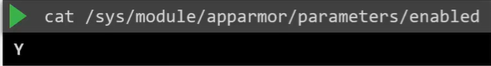

AppArmor profiles defines what resources can be used by an application

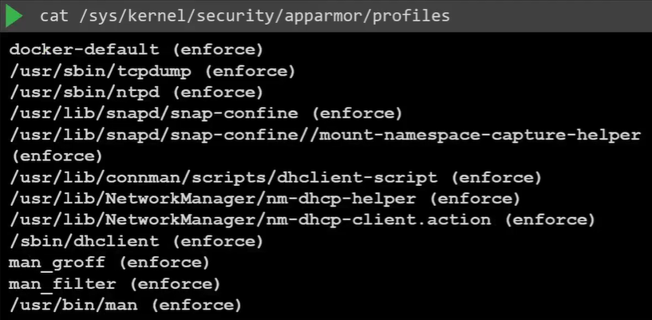

Apparmor-deny-write profile contains 2 rules:

file: allows complete access to the entire file system

deny: prevent write access to all files under the root file system

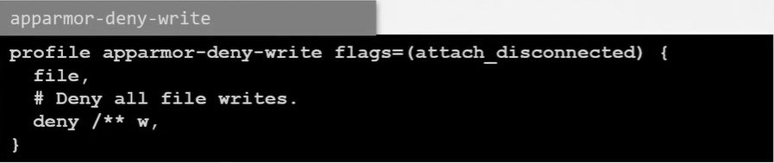

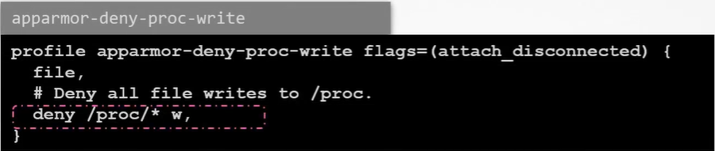

Check Apparmor loaded profiles and its status

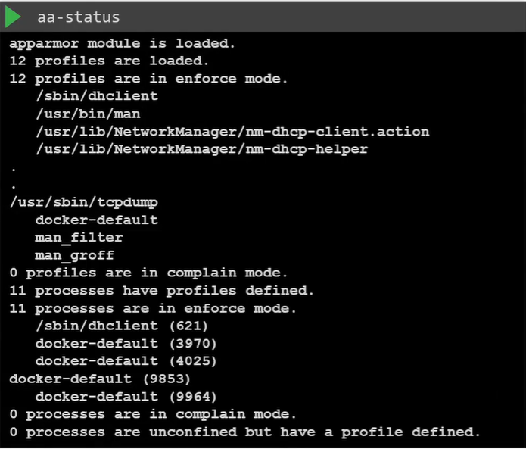

Enforce mode: apparmor will monitor and enforce the rules on any application that fits the profile.

Complain mode: apparmor will allow application to perform tasks without any restriction, only log them as events.

Unconfined mode: apparmor will allow application to perform tasks without any restriction and not log them as events

1. Create custom application-specific profiles

Use apparmor-utils

* 1. Create a script as an APP

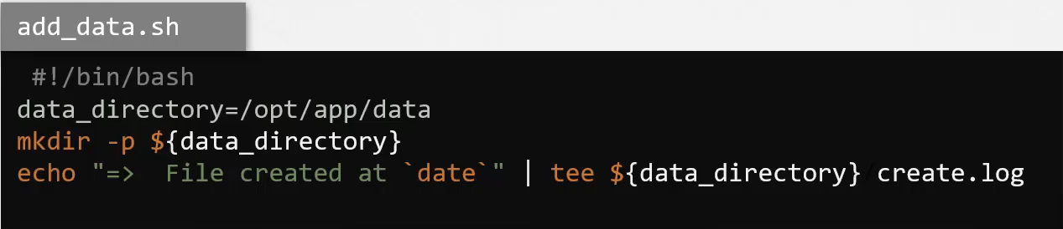

* 1. Create a profile for add_data.sh

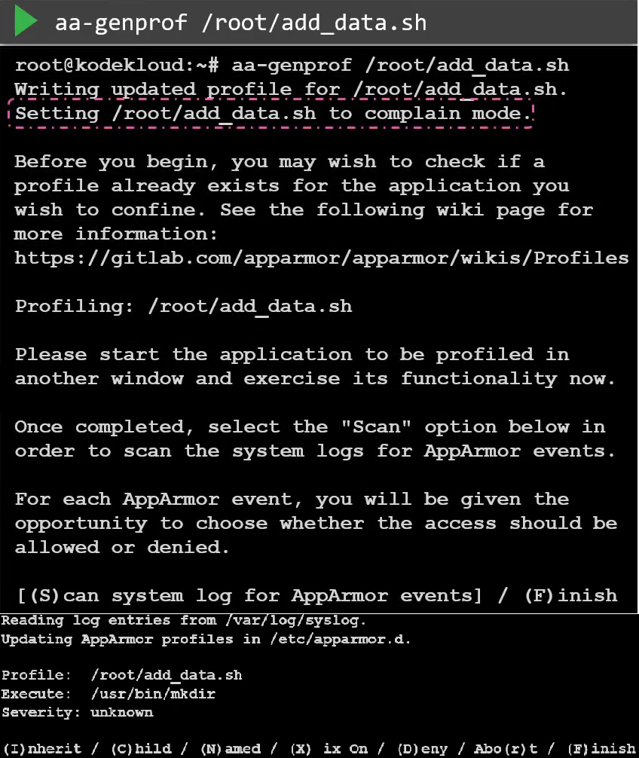

To grant access for mkdir command, need select “Inherit”, enter “I”. do the same for the next event until create the profile

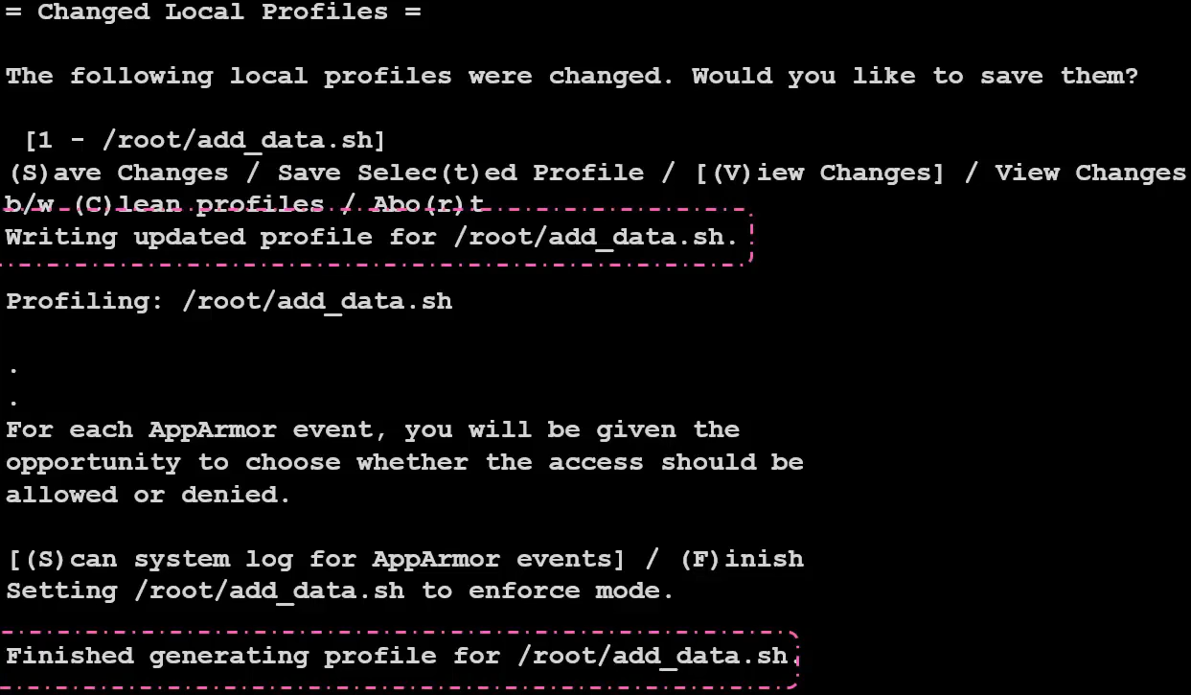

Check newly create profile

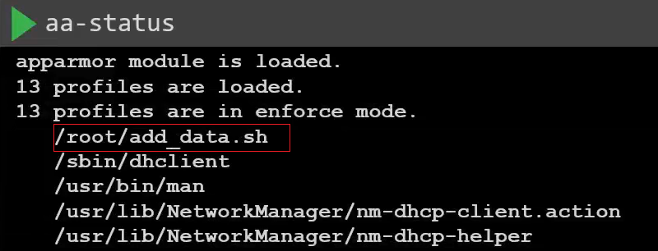

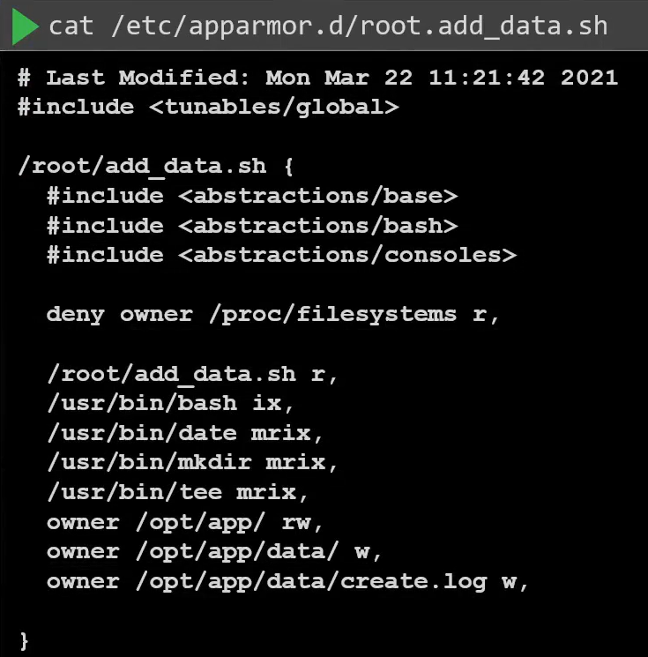

When change the “data_directory” from “/opt/app” to “/opt” of add_data.sh, the script will be permission denied.

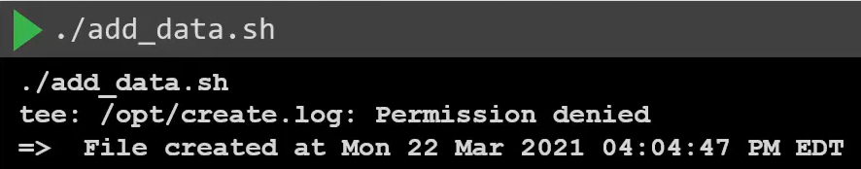

* 1. Check if the profile is loaded successfully

Success:

Add Profile

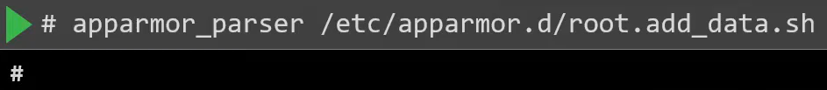

* 1. Disable the profile





1. AppArmor in K8S

2.0. Prerequest

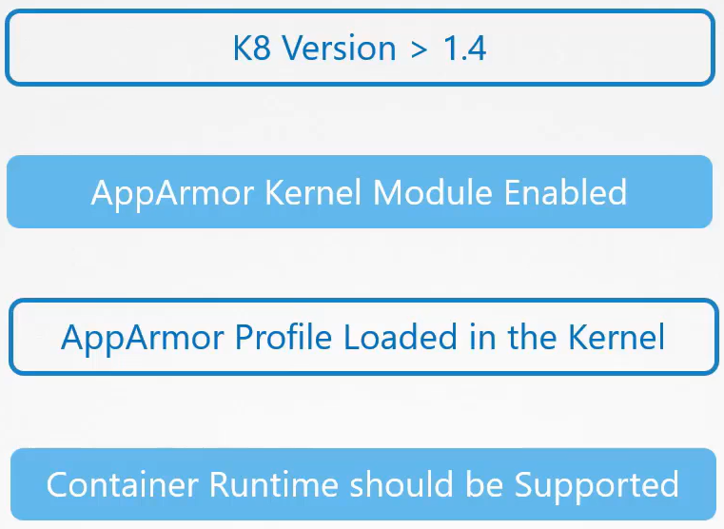

2.1.

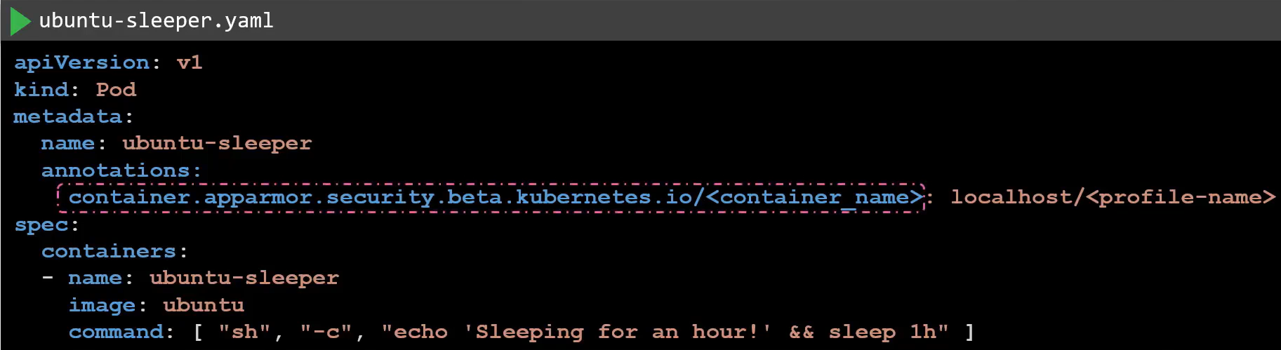

1. Add/Drop Linux Capabilities on K8S pods

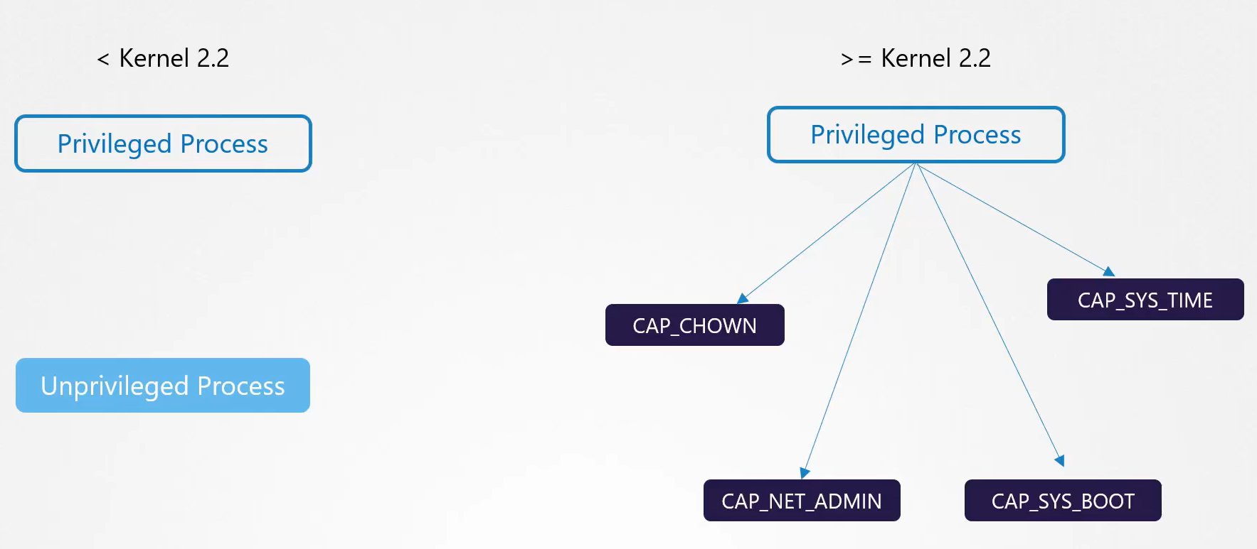

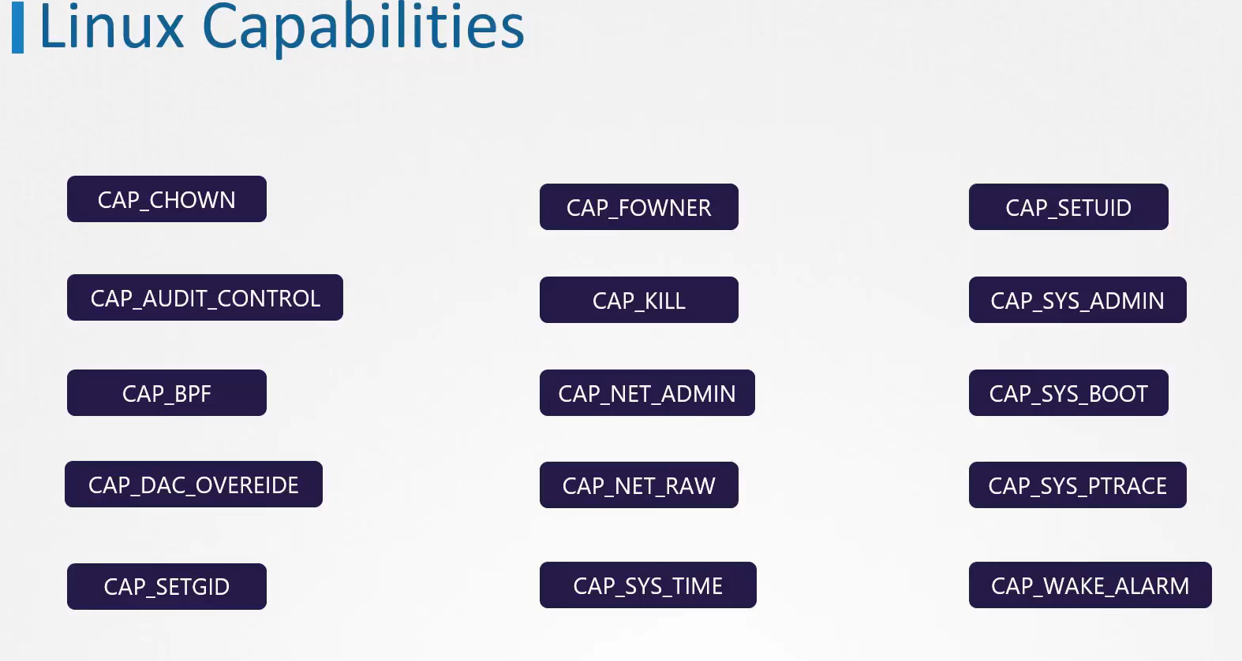

Check which capabilities the command needs:

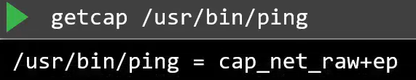

By PID

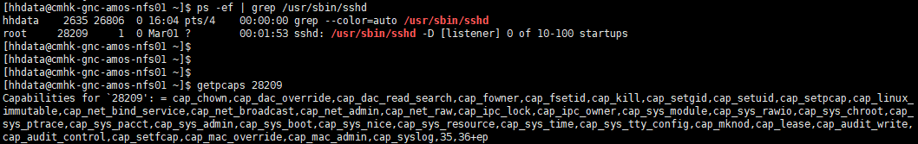

When start docker container, it only grant some of capabilities.

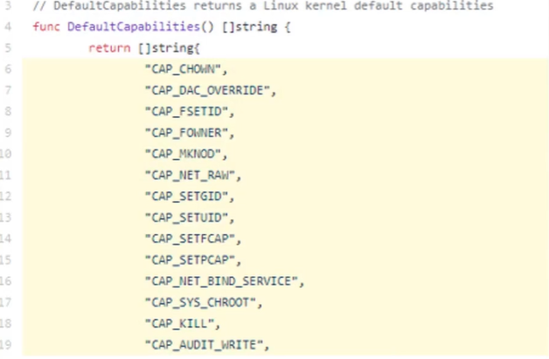  
3.1. Change capabilities when start the container

